**ID-8**

**CAmel POC**

*Origin/Author* **: Bhushan Deshpande & Shekhar Agrawal**

*Reviewed by* **: Sundeep Kumar**

*Approved by* **: Sundeep Kumar**

*Date Approved* **:**

*Version* **: 1.0**

Contents

1. Introduction 3

1.1 POC Use Case 1 3

1.2 Technologies used for Camel POC:……………………………………………………………………..…………………………4

2. CAMEL Solution: 4

3. Effort Spent: 9

4. References: ………………………………………………………………………………………………………………………………………………10

# 

# Introduction

The purpose of this document is to provide a detailed level description of the design components necessary to build DOP ID-8 CAMEL POC. The document will include POC Use case and used Apache Camel to complete the use case integration between monitoring tools, ITSM and AIOPS using Publish-Subscribe.

The present document is a technical architecture design document of this integration and aims to describe from a detailed level point of view all general principles of the underlying architecture and technical choices.

### 1.1 POC Use Case 1 ( [Swagger.yaml file](swagger.yaml) )

HLD (High Level Diagram) of an alert generated and published from monitoring tools to the respective destination ITSM or AIOPS.

HLD:

Alert API

Pub

-

Sub

Service

Rabbit MQ

Queues

ITSM

-

proxy

Service

AIOPS

-

proxy

Service

1.2 **Technologies used for Camel POC:**

• Java 8

• Camel

• Spring Boot

• RabbitMQ

# 2. CAMEL Solution:

It can be summarized as follows:

·       **Alert API** receives the generated alert by monitoring tool.

·       The Alert API will route the monitoring message to **PubSub Service**.

·       After that the PubSub Service will push the monitoring message to the **RabbitMQ queues**, i.e. it will create a **topic exchange** with queues connected to the exchange through routing keys.

·       Then **ITSM Proxy** and **AIOPS Proxy** already subscribed to the topic will consume the message from their respective queues.

Low Level Diagram(LLD) of Use Case 1: -

1. Alert API- Basic structure

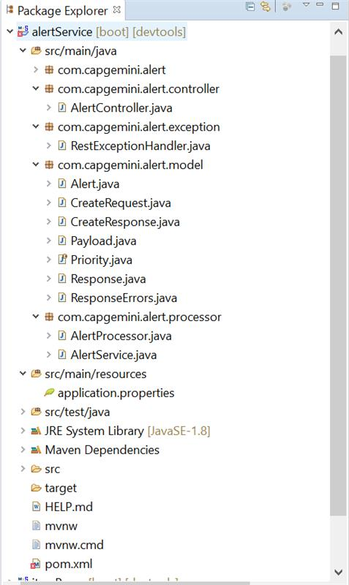

POM file of alert API-

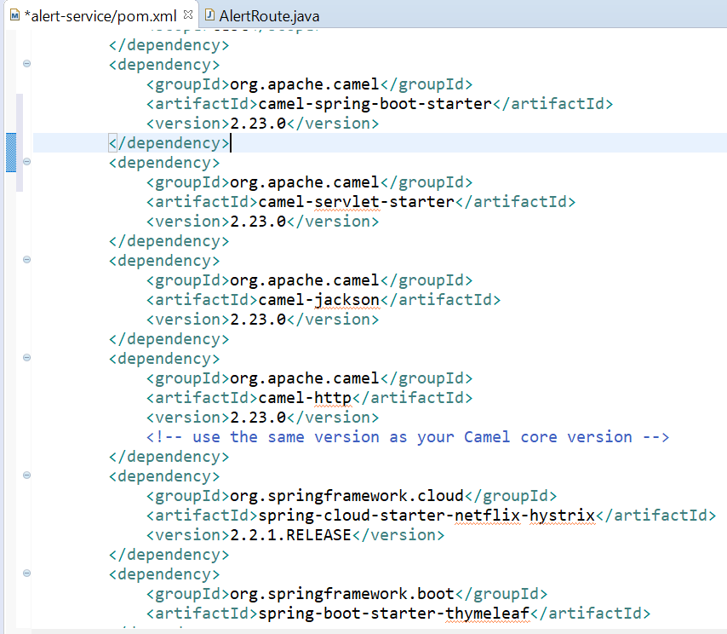

pubsub Service- Basic structure

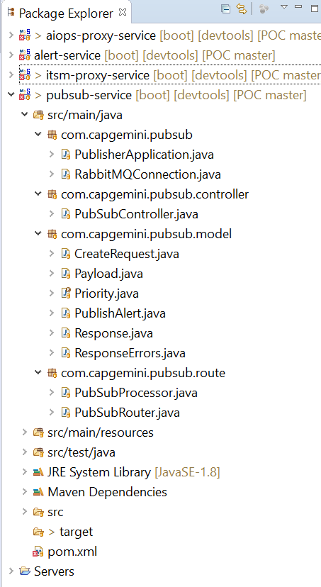

POM file of pubsub service-

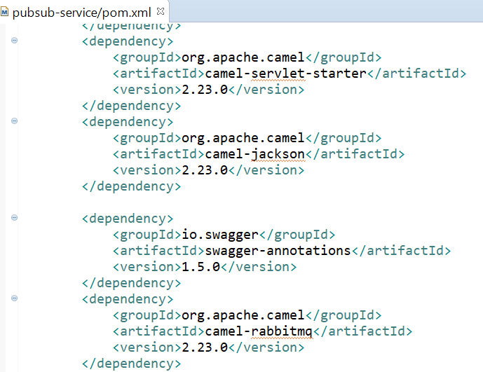

1. ITSM Proxy Service-

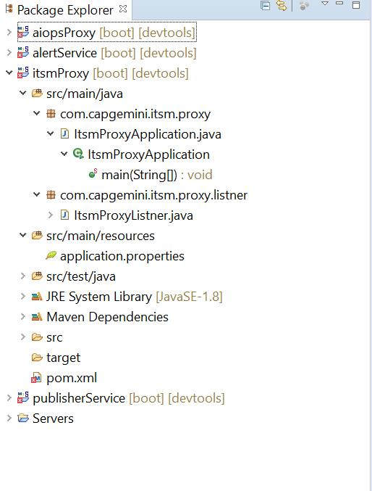

1. AIOPS Proxy Service-

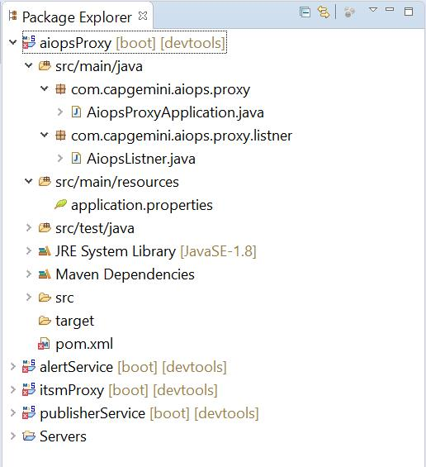

# 3. Effort Spent:

|  |  |  |  |
| --- | --- | --- | --- |
| S.NO | Task | Description | Total Effort (hrs) |
| 1 | Alert API | Manages incoming messages from monitoring tool/ITSM and sends the payload to Pub Sub API | 1 |
| 2 | Pub Sub API | Route the payload to the Pub Sub Micro Service and manages subscription | 2 |
| 3 | Setup Rabbit MQ | 1. Installed RabbitMQ and Integrated with Camel | 2 |
| 4 | Pub Sub Micro Service | Is connected to the RabbitMQ and also has the responsibility to produce message onto the queue via topic | 3 |
| 5 | ITSM micro service | Consumed message is delivered to Endpoint | 0.5 |
| 6 | AIOPS micro service | Consumed message is delivered to Endpoint | 0.5 |
| Total Hours | | | **9** |

Time for Research and Development = 20 hours

Time for performing the tasks = 9 hours

Total time taken to complete the usecase1 = 29 hours

**4. References:**

1. Setting up Camel with spring boot-

<https://mvnrepository.com/>

<https://www.baeldung.com/apache-camel-spring-boot>

<http://www.javaoutofbounds.com/apache-camel-springboot-rest-api-example/#more-411>

1. Swagger file-

<https://swagger.io/tools/swagger-editor/>

1. Starting with RabbitMQ-

<https://cmatskas.com/getting-started-with-rabbitmq-on-windows/>

<https://www.youtube.com/watch?v=h8b1dXgPulQ>

1. Spring boot + Camel + RabbitMQ-

<https://camel.apache.org/camel-spring-boot/latest/spring-boot.html>

<https://camel.apache.org/components/latest/amqp-component.html>

<https://camel.apache.org/components/latest/rabbitmq-component.html>

1. Topic Exchange-

<https://codedestine.com/rabbitmq-topic-exchange/>

1. Publishing and consuming of messages-

<https://www.rabbitmq.com/api-guide.html#consuming>

<https://camel.apache.org/manual/latest/polling-consumer.html>

Document Control

**Version History**

|  |  |  |
| --- | --- | --- |
| ***Version*** | ***Date*** | ***Comments*** |
| 0.1 | 02/03/2020 | Created document with Usecase1 |
|  |  |  |
|  |  |  |
|  |  |  |
|  |  |  |